Nectar-feeding bats learn the rule behind serial reversals

# Results

## Confirmatory analyses

### Bats made a very high proportion of their visits to the rewarding option

The bats made a large number of visits to an option when it was rewarding, and when it stopped being rewarding after a reversal they abandoned it within 10 visits to switch to the other. (Figure 2). A consistent pattern emerged over all three nights: a sharp decrease in the proportion of visits to the formerly rewarding option immediately following a reversal, concomitant with a rapid increase in visits to the newly rewarding option. There are two particularly interesting points about this overall pattern: the behaviour during the first bins of each block; and the changes between the first night and the following two nights.

At the start of the first night, in the very first bin of ten visits when the bats did not yet have any information about the available options and had never experienced a reversal, the Proprew (the proportion of visits to the rewarding option) averaged across individuals was close to chance: 54.5% [95% CI: 46.8–62.3]. Within the next ten visits however, Proprew increased to 92.1% [95% CI: 87.1–96.4] and by the last bin of this first block was 99.3% [95% CI: 97.9–100]. Immediately after the first experience of a reversal, the Proprew dropped down to 13.6% [95% CI: 8.4–18.8] in the first ten visits but came back up to 96.4% [95% CI: 92.9–99.3] by the last bin of this block.

At the very start of the second and third nights, in the first bin of visits before any experience of a reversal on that night, the average Proprew of all the bats was 69.8% [95% CI: 64.6–74.7]. This was significantly higher than random choice and higher than the Proprew in the corresponding bin of the first night. However, the Proprew on the second and third nights also showed the pattern of a decrease immediately after a reversal and then increase to a high proportion overall at 94.8% [95% CI: 94.1–95.5], comparable to the 93% [95% CI: 91.8–94.1] on the first night.

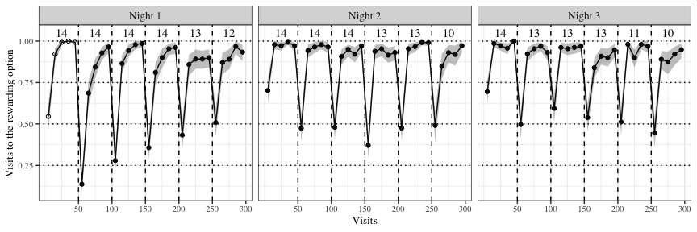

Figure 2: Visits to the rewarding of two options across the three experimental nights. Data are average proportions for bins of ten visits averaged over all 14 individuals. Data are indicated by white points in the first block on the first night before the bats had experienced any reversals; the bin averages of the other blocks are indicated by black points. Numbers indicate the bats that participated in a block. Shading shows 95% confidence intervals. Dashed lines show reversals

### Bats switch to the rewarding option faster as they experience more reversals

As the bats experienced more reversals, they made their first visit to the rewarding flower faster and faster. Immediately after a reversal, the number of visits to the previously-rewarding flower (perseverative visits) decreased as the animals experienced more reversals (Figure 3). The data however indicates that this decrease did not persist on the second and third nights. It would appear therefore, that the bats got faster at responding to reversals only on the first night until they reached a plateau, which persisted over the second and third nights.

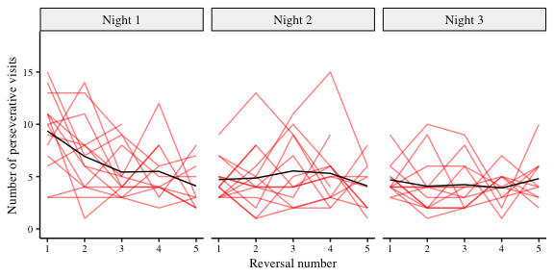

Figure 3: Number of perseverative visits made by the bats after each reversal across all three nights. A perseverative visit is a visit to the previously-rewarding option after a reversal and before any visit to the newly-rewarding option. By definition, there were no perseverative visits in the first block of a night. The red lines show individual data; the black lines, the group average (N = 14). Reversals were between the two flowers assigned to an individual bat

The results of the statistical analysis are summarized in Figure 4 and Figure 5. The bats made fewer perseverative visits as they experienced more reversals and more experimental nights, but this effect on perseverative visits decreased until a plateau was reached by the second experimental night. Overall, though the bats ‘improved’, there was no evidence that the number of perseverative visits decreased to one per reversal, the optimum performance.

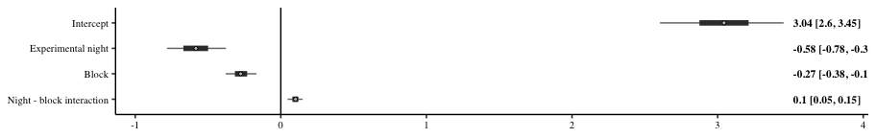

*Figure 4: Forest plot of the estimates of the effect of night and block on perseverative visits. Circles ( ) represent the means of the posterior distributions of the slope coefficients, thick horizontal lines represent 50% credible intervals; thin horizontal lines, 89% credible intervals. The numbers in bold are the means of the posterior distributions and 89% credible intervals*

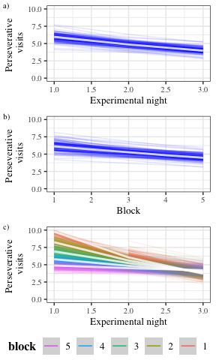

*Figure 5: Conditional effects plots from the model of the perseverative visits showing the effect of the predictors and interaction conditional on the value of the other predictors being equal to their mean, sampling from the posterior distribution. a) Conditional effects of experimental night on the number of perseverative visits b) Conditional effects of block on the number of perseverative visits c) Conditional effects of the interaction of experimental night and block*

### Bats make more visits to the rewarding option overall as they experience more reversals

As the experiment proceeded and the bats experienced more reversals on more nights the overall proportion of the animals’ choices for the rewarding flower changed (see Figure 2). Within each block, the effect on the Proprew was very large, increasing rapidly from less than 0.7 at the start of a block, when the animals had either experienced the start of the experimental night or a reversal, to more than 0.9 by the second bin of 10 visits. Across the three nights, the animals were more likely to choose the rewarding flower. However there was a decrease within each night in the Proprew: the bats made slightly fewer visits to the rewarding flower at the end of the night compared to the start of the night.

The results of the statistical analysis are summarized in Figure 6 and Figure 7. The bats made an increasing number of visits to the rewarding option as each block progressed from its start to the next reversal, and as they experienced more experimental nights. However this increase was dampened over the course of each individual night.

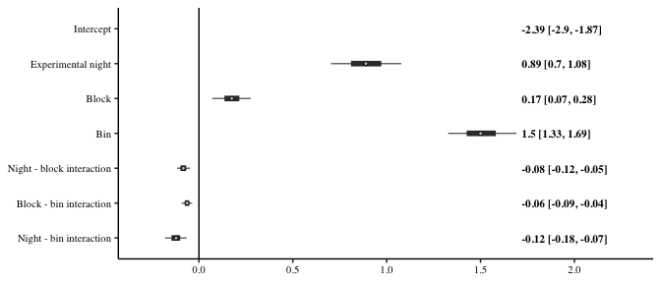

*Figure 6: Forest plot of the estimates of the effect of night, block, bin and their two-way interactions on the Proprew. Circles ( )represent the means of the posterior distributions of the slope coefficients, thick horizontal lines represent 50% credible intervals, and thin horizontal lines 89% credible intervals. The numbers in bold are the means of the posterior distributions and 89% credible intervals*

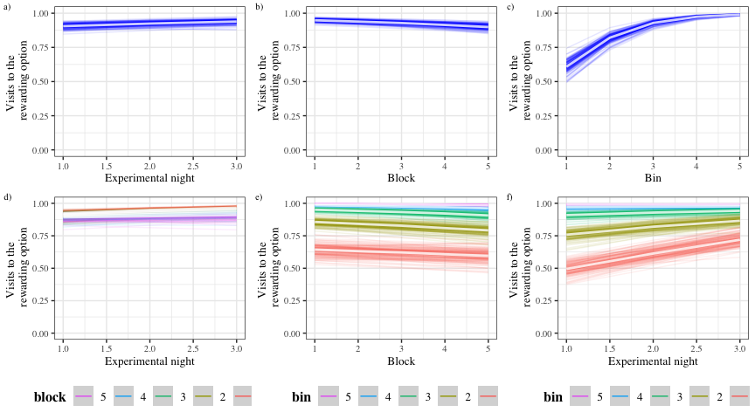

*Figure 7: Conditional effects plots from the model of the Proprew showing the effect of the predictors and interactions conditional on the value of the other predictors being equal to their mean, sampling from the posterior distribution. a) Conditional effects of experimental night on the Proprew b) Conditional effects of block on the Proprew c) Conditional effects of bin on the Proprew d) Conditional effects of the interaction of night and block on the Proprew e) Conditional effects of the interaction of block and bin on the Proprew f) Conditional effects of the interaction of night and bin on the Proprew*

## Exploratory analyses

### Effect of the first experimental night and the first block of each night

The first block of an experimental night was qualitatively different from the other blocks, as this was the only part of the night when the bats had not yet experienced a reversal. A similar argument can be made about the very first experimental night: before this night the bats had never experienced a reversal at all. Therefore, after examining the results of the analyses described above, we performed further analysis to specifically explore the effects of the first block of a night and the first night.

The results of this analysis were consistent with the results of the confirmatory analysis, summarized in Figure 8 and Figure 9. The first block of a night had an effect on the Proprew: the bats made more visits to the rewarding option in the very first block of a night compared to all the later blocks. This effect was greater on the very first night compared to the later two nights, i.e., on the very first block of the very first night when the bats had experienced reward at only one option, and no reversals at all.

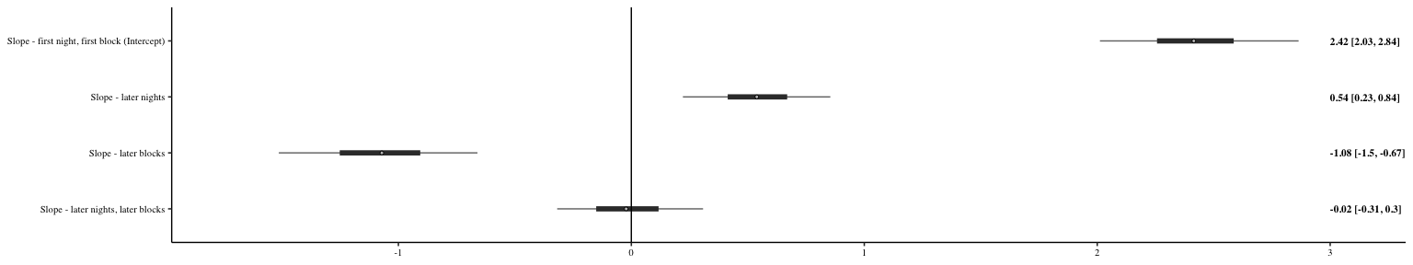

*Figure 8: Forest plot of the estimates of the effect of night, block, bin and their two-way interactions on the Proprew. Circles ( ) represent the means of the posterior distributions of the slope coefficients, thick horizontal lines represent 50% credible intervals; thin horizontal lines, 89% credible intervals. The numbers in bold are the means of the posterior distributions and 89% credible intervals*

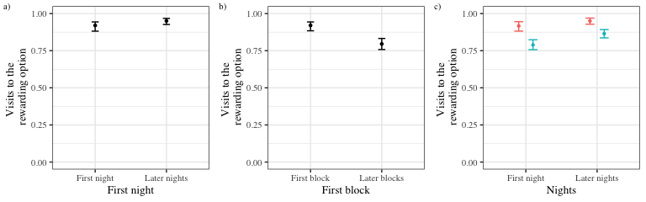

Figure 9: Conditional effects plots show the effect of a particular predictor or interaction conditional on the value of the reference category of the predictor variables, sampling from the posterior distribution a) Conditional effects of first and later experimental nights on the Proprew b) Conditional effects of first and later blocks on the Proprew c) Conditional effects of the interaction of the first and later nights and first and later blocks on the Proprew

## Electronic Supplementary Material

## Visits and approaches to the unassigned flowers

Only two out of the array of eight flowers were assigned uniquely to each bat; however, all the flowers were accessible to all the animals. The number of approaches to and attempts to get a reward from all the flowers, both assigned and not assigned, is shown in Figure 10.

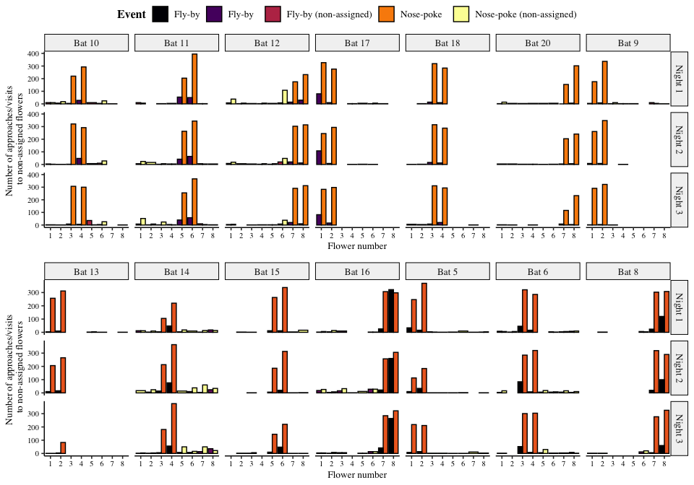

Figure 10: Visits made by the bats to all the flowers, including the ones that were not assigned to them. Yellow bars are nose-pokes at the assigned flowers, where the bats attempted to get a reward by breaking the light-barrier. Purple bars are ‘fly-by’ events near the assigned flowers where the bat flew near the flower but did not attempt to get a reward. Orange bars are nose-pokes at the non-assigned flowers and black bars are fly-bys at the non-assigned flowers.

The number of approaches or attempts to get a reward at the non-assigned flowers was a small proportion of the overall number of approaches and reward-attempts at the flowers, less than 10% every night on average, as shown in Figure 11.

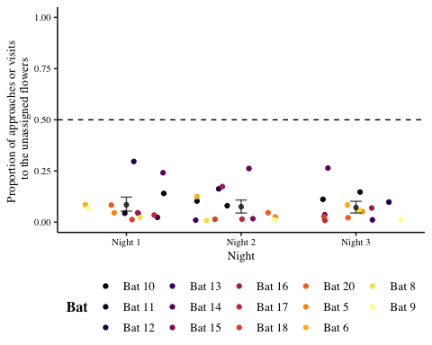

Figure 11: Proportion of visits or approaches to the un-assigned flowers out of the total number of visits or approaches to flowers. Coloured points are data from individual bats. Black points are the mean proportion per night and the error bars are 89% CIs

## Details of the statistical analyses

Weakly informative priors were used for the generalized linear mixed-models in brms. The random intercepts and slopes were given a normal distribution with a mean of 0, and a standard deviation drawn from a Cauchy distribution with a mean of 0 and a standard deviation of 1. All the models were estimated using 4 chains with a thinning interval of 3, with 1200 warm-up samples and 1200 post-warm-up samples for the model with the first experimental night and block treated differently; 2000 warm-up samples and 2000 post-warm-up samples for the model of the first bin of 10 visits after a reversal; and 1000 warm-up samples and 1000 post-warm-up samples for the others.

For the model investigating the effect of experimental night and block on the number of perseverative visits, a negative-binomial likelihood function was used. Experimental night, block and their interaction were fixed effects; random slopes and intercepts were used to fit regression lines for each individual animal.

The model investigating the effect of experimental night, block and bin on the Proprew (calculated only over the two flowers assigned to a bat) used a binomial likelihood function with experimental night, block, bin, and their interactions as fixed effects; random slopes and intercepts were used to fit regression lines for the individuals. The model of the change in Proprew in the exploratory analysis also used a binomial likelihood function with only night and block and their interaction as fixed effects; random slopes and intercepts were used to fit regression lines for the individuals. The first night and the first block of every night was treated as one level of the categorical variables and the other nights and other blocks of each night as the other level. The first night and first block were the reference categories.

Visual inspection of the trace plots, the number of effective samples, the Gelman–Rubin convergence diagnostic ($\hat{R}$) and the calculation of posterior predictions for the same clusters were all used to assess the fit of the models. In all of the models, the $\hat{R}$ was equal to 1 for all the chains.

## Posterior predictive checks of the model of the Proprew

We carried out a posterior predictive check of the confirmatory model of the Proprew in order to check the models’ descriptive adequacy—the agreement of the models with the empirical data—which is a basic goal of modeling [@shiffrin_survey_2008]. Posterior samples from the posterior predictive distribution were computed for the data used to fit the models and plotted in Figure 12. A visual comparison of the two reveals a close correspondence between the data and the posterior samples of the model.

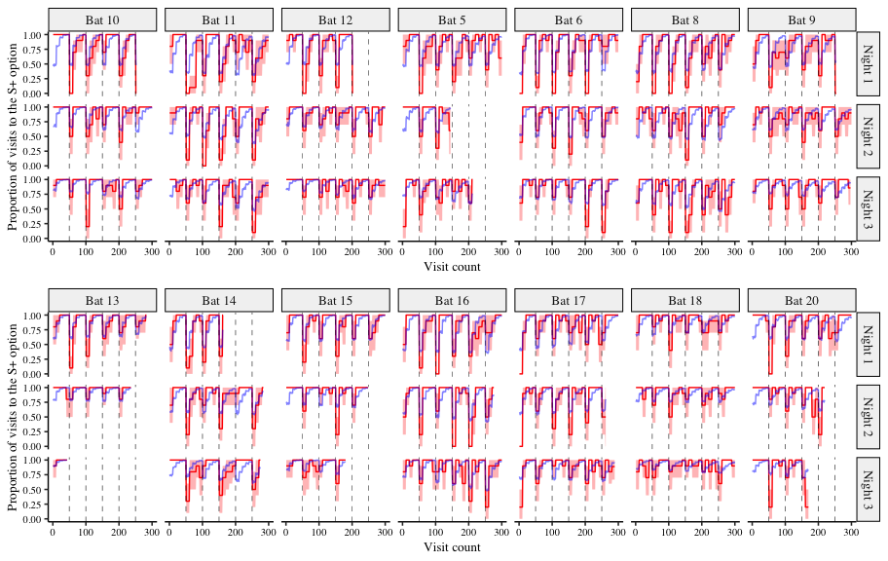

Figure 12: A comparison of the posterior predictions of the generalized linear mixed-effects model of the visits to the rewarding option and the empirical data from the bats. The red line indicates the average proportion of visits to the rewarding option per bin made by the individual bats, with the red shading indicating 95% confidence intervals; the blue line indicates the corresponding posterior prediction of the model